**SOFTWARE AND HARDWARE REQUIREMENTS**

This section outlines the software and hardware requirements for the system.

Face recognition and fingerprints have been developed as an extra means to access the account in this suggested system. Fingerprints and images of the face are used in this method. The face image of a person is used to authenticate the person. After that, the picture was compared to the database image, and finally the image was compared to the database image. Fingerprint recognition When both recognition techniques are used access to the account if you match with the same single person. will be made available. In this case, the Raspberry Pi microcontroller is employed. the portion in charge Ids for fingerprint scanners and facial recognition are both available. searched a database for the user's additional information. The account will be kept. The Raspberry Pi is a small computer with a microcontroller. carries out a database search and sends the results to a display device the information that is required

**SOFTWARE REQUIREMENTS**

* Windows 7 is suitable for this system. Because Windows-7 is more reliable, has more functionality, and is more user-friendly, it is used as the operating system.
* MySQL/No SQL is used as a database because it is straightforward to manage and retrieve entries using basic English queries that are easy to comprehend and construct.
* Programming languages and development tools The WWE code and Web pages are written in JavaScript and HTML, including JavaScript for styling and PHP for server-side scripting.

**HARDWARE REQUIREMENTS**

* Raspberry pi.
* We can continue to work on our project without any issues if we use the Intel Atom(or) Intel Dual Core Processor.
* A minimum of 512 MB of RAM and 1.10 GB of free space are required (or more).
* Fingerprint sensor requires.
* Camera requires for face identification.

**Raspberry pi: -**

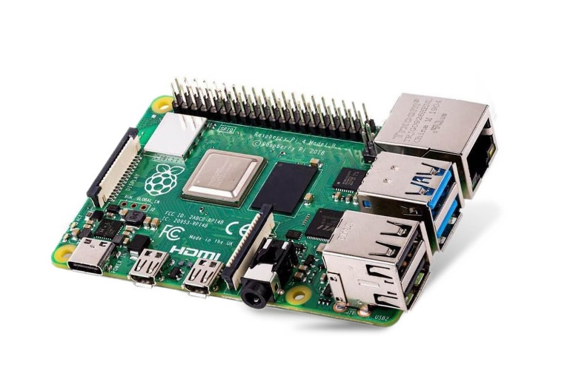

The Raspberry Pi Foundation created

a series of compact single-board computers

in the United Kingdom to support the teaching

of fundamental computer science

in schools and underdeveloped nations.

The first model was a lot more popular than predicted,

and it was sold for things like robotics outside of its original market. It excludes all extraneous items (such as keyboards, mice, and cases).

On the other hand, several accessories have been included in a variety of official and unofficial bundles. The Raspberry Pi Foundation recommends Raspbian, a Debian-based Linux operating system. The official website offers third-party operating systems like as Ubuntu MATE, Windows 10 IoT Core, RISC OS, and special editions for the Kody media center and classroom management. A variety of different operating systems may be run on the Raspberry Pi.

**Web Camera: -**

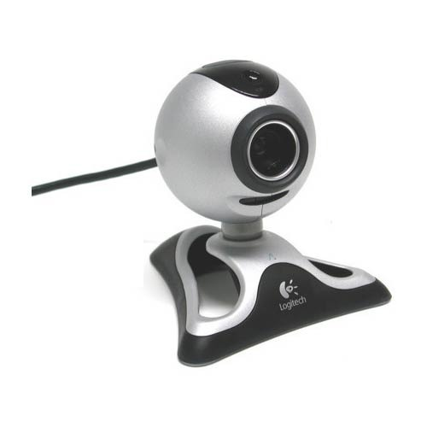A web camera is a device that allows you to take pictures and record movies.

It's often used for video conferencing

and picture and video capture for

authentication and verification.

In Our prototype, the Logitech camera,

is used to carry out this method.

It is one of the most cost-effective

and useful web cams available. market.

Other cameras can also be used to record faces.

The Logitech camera includes a 5MP sensor and can record video in 720p. capturing a picture A 5MP picture is more than plenty for a decent shot. The face of the individual is identified.

The camera, which is often used, supports USB 2.0 serial communication. Consequently, integrating this camera into the system is straightforward. There is no need to download the camera's driver software separately. The universal driver, which is available for all operating systems, will support the Logitech web camera. There is no need to install any additional drivers for the Logitech camera.

**Fingerprint sensor: -**

The fingerprint sensor is the project's most

crucial component. Face recognition is used

to identify a person in the same way that

fingerprints are important for identification.

Consider the case of identical twins,

in which the facial image is crushed and

the account is recognized via fingerprint ID.

Although fingerprint identification is more reliable, gesture identification is being used to separate people with similar appearances. It is impossible for two persons to have the same fingerprint since they are formed based on a variety of factors.

**Proposed system**

**Data Base**

**Raspberry pi**

**Power Suply**

**Face Image**

**Web Camera**

**LCD Display**

**Request to ATM Machine**

**Fingerprint**